|  |
| --- |
| **FFT** |
| **Students :** Roy Shvadron, Omri Freund  **Supervisor :** Goel Samuel  **Semester :** Winter 2017 |
| **Project Description :**  Diagnostic ultrasound has been used for decades to visualize body structures. As we all probably know, the ultrasound machines are of great size, cost and power consumption. SAMPL lab results prove that using Sub-Nyquist sampling can port the heavy computational tasks to the cloud is feasible for medical ultrasound, leading to potential of considerable reduction in future ultrasound machines size, power consumption and cost. The mixed signal solution of the ultrasound cloud processing includes an ASIC which is comprised of Buffer 🡪 Mixer 🡪 Digital LPF 🡪 buffer 🡪 FFT engine 🡪 buffer.    The goal of this project is to implement the second half of the signal path :  Buffer 🡪 FFT engine 🡪 buffer. The implementation should include an efficient VLSI architecture for the FFT engine. |

**Project Specifications:**

* Clock Frequency : 150 MHz
* Area : 5x5 sq. mm
* Maximum number of IOs : 120
* Technology : TSMC 16nm FINFET CMOS

**Project Requirements:**

* Efficient architecture
* Meeting timing requirements
* Maximum silicon area efficiency
* Minimal output error
* Synthesis
* Physical design (layout)

|  |  |
| --- | --- |
| **Development Stages / Design Flow** | **Tools** |
| Software Simulation | Matlab |
| Architectural and Logic Design |  |
| HDL Implementation | Verilog |
| Functional simulation | Ncsim/VCS |
| Synthesis | Design Compiler |
| Layout Design | First Encounter |

**Literature**

**Alternative solutions**

**Selected solution**

**Top Level Interface**

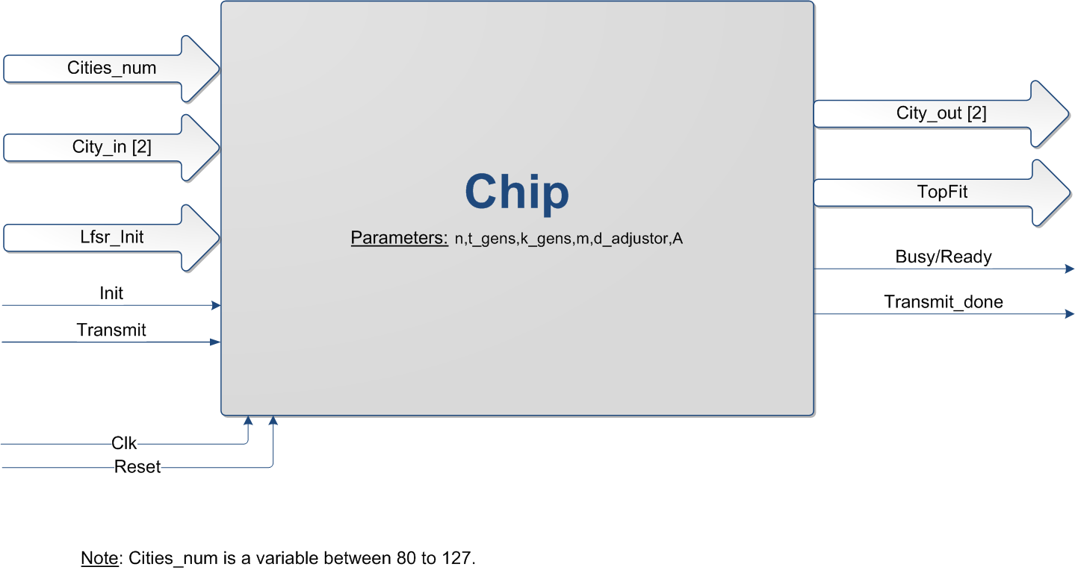

**Top Level Architecture**

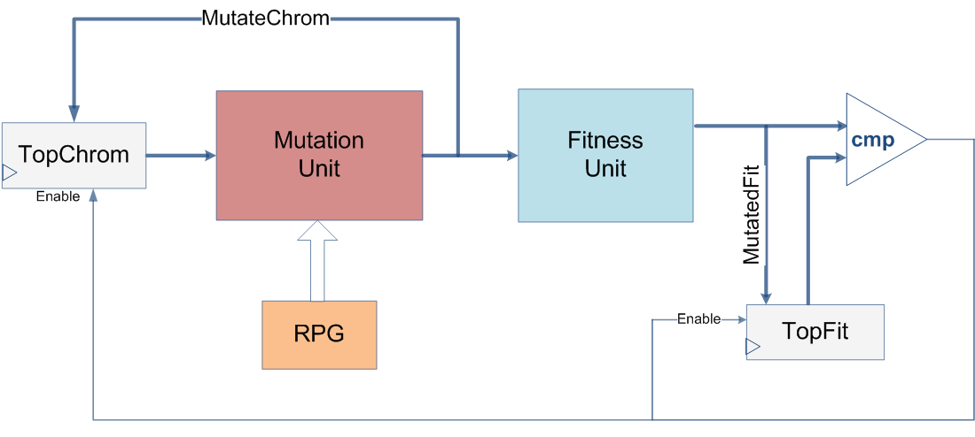

|  |  |
| --- | --- |
| **Provisional/Preliminary Schedule**  Task A  Task B  Task C  Task D  Task E  Task F | **Week**  1-3  3-5  6-9  9-12  13  14 |

Please prepare a Gantt chart as follows: Gantt Chart Example:

Week 1 2 3 4 5 6 7 8 9 10 11 12 13 14 15

Software Simulation

Architectural and Logic Design

HDL Implementation

Functional simulation

Synthesis

Layout Design

Report